Download IntelliJ, Maven, Postman

Proxy to see web broswsing of others in http protocol
https is a solution, it decode the request message
start spring initializr [[start.spring.io]]
+ skeleton of a web application
+ Set default: Project, Language, Spring Boot
+ Change project metadata
+ Dependency -> Spring Web, H2 Database, Lombok
+ Tomcat is a web server. A server that serve http protocol
- Press Generate and unzip the downloaded file

Open IntelliJ
+ Open the unzipped folder in IntelliJ
+ mvnw or ./mvnw in *terminal* and wait for the dependencies downloading finished. If JAVA_HOME is missed then add java JDK as JAVA_HOME variable:
+ set path variable by going to Environment Variable panel, in User variables >New
+ Set variable name to be JAVA_HOME, and variable value to be the JDK path directory (In windows it is C:\Program Files\AdoptOpenJDK\jdk-11.0.8.10-hotspot)
+ In terminal run ./mvnw spring-boot:run to run the server. Ctrl-C to stop the server.
+ Open in web browser localhost:8080, it should display “Whitelabel Error Page”
Under src/main/java… create a new class name StudentController.java
#+BEGIN_SRC java
package com.se2020.studentrest;

import org.springframework.web.bind.annotation.GetMapping;
import org.springframework.web.bind.annotation.PathVariable;
import org.springframework.web.bind.annotation.RestController;

// Annoation is something that tells the compiler to do exrta work
@RestController // this annotation tells the compiler that this is a controller
public class StudentController{
@GetMapping("/student/{id}") // tell the controller you are serving get method,
// matching the pattern and doing he logic
// @PathVariable: map {id} to String studentID

public String getStudent(@PathVariable(name = "id") String studentID){
return "Student " + studentID;
}
}
#+END_SRC
Test with http://localhost:8080/student/0 and the return String should be “Student0”
+ Create a Student.java describes Student object
#+BEGIN_SRC java
package com.se2020.studentrest;

public class Student {
private long id;
private String name;
private String role;

Student(String name, String role){
this.name = name;
this.role = role;
}

public void setID(long id){
this.id = id;
}
public void setName(String name){
this.name = name;
}
public void setRole(String role){
this.role = role;
}

public long getID(){
return this.id;
}

public String getRole(){
return this.role;
}

public String getName(){
return name;
}
}

#+END_SRC
+ Add to application.properties the following codes
#+Begin_src java
spring.datasource.driverClassName=org.h2.Driver
spring.datasource.username=sa
spring.datasource.password=password
spring.jpa.database-platform=org.hibernate.dialect.H2Dialect
spring.datasource.url=jdbc:h2:mem:testdb
spring.h2.console.enabled=true
spring.h2.console.path=/h2-console
#+end_src
+ Recompile the server
+ To access the database, go into http://localhost:8080/h2-console, a Login window should appear on the site
jdbc:h2:mem:testdb
sa
password

// When working in big project with hundred of entities and controllers, it’s a good practice to put all the entity in a separated entity package so that it is easier to navigate in the project. Same reasons for Controller file
+ Move Student.java to entity subfolder under java/com/se2020/studentest
+ move Controller.java into controller subfolder java/com/se2020/studentest
+ Add this dependency to pom.xml to provide @Entity annotation
<dependency>
<groupId>org.springframework.boot</groupId>
<artifactId>spring-boot-starter-data-jpa</artifactId>
</dependency>

Reload the dependency in IntelliJ by right click on the right panel -> Maven -> Reimport/Reload. Or in VSCode right click in pom.xml and select Update project configuration
In Student.java
import javax.persistence.Entity;
import javax.persistence.Id;
import javax.persistence.GeneratedValue;

and add the following @Annotation
@Entity
public class Student {
@Id //use field Id for Id table
@GeneratedValue

Now go into go into http://localhost:8080/h2-console to access the database
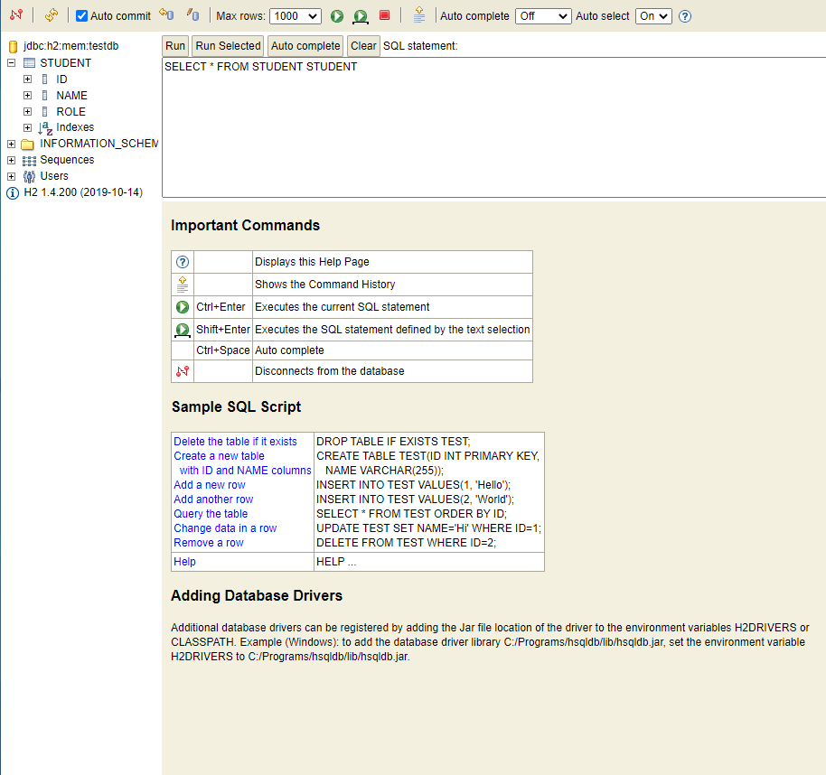
Notice that in STUDENT table, there are already 3 fields ID, NAME, ROW
If there is no STUDENT table: check bugs and fix in the .java files
Open Postman click the (+) button and try
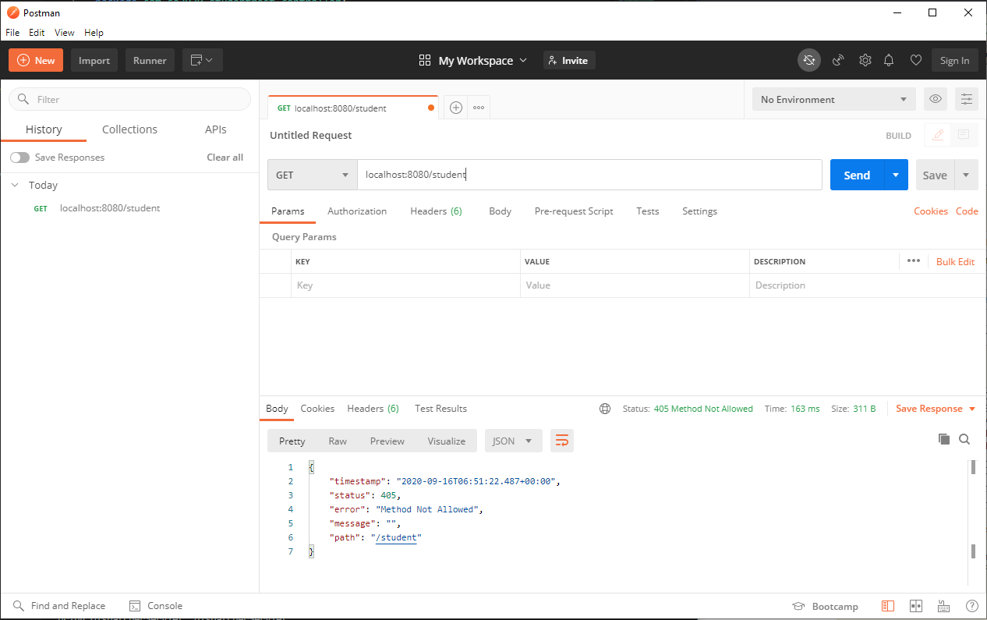
Add more code to StudentController.java
@PostMapping("/student")
public String saveStudent(@RequestBody Student student){

return "Success";
}

Restart the server and move back to Postman
Change request to POST and post the url localhost:8080/student
Move to Headers bar and fill in Content-Type in KEY and application/json in VALUE
Move to Body and in raw, paste the following
{
"name" : "Phuc",
"role" : "Student"
}
Click SEND, it should display “Success” in the response area at the bottom
Create new interface StudentRepository.java under new folder repository. Let it there and Spring can do all the magic for us
package com.se2020.studentrest.repository;

import com.se2020.studentrest.entity.Student;
import org.springframework.data.jpa.repository.JpaRepository;

public interface StudentRepository extends JpaRepository<Student, Long> {

}

Try the Postman POST again, the Success message comes up and check the database
SELECT*FROM STUDENT and <Run>. It should display a table contains the data we just put in with POSTMAN. However, if we restart the server, the data is lost because we save the data in the RAM. We need to save it inside a database by modifying the properties:

spring.datasource.url=jdbc:h2:~/teaching/se2020/java/demo/testDB;DB_CLOSE_ON_EXIT=FALSE;DB_CLOSE_DELAY=-1;

If testDB is not exist it will create one. testDB is a database-structured file, in binary that supports SQL queries.

Add the following code for GET request only and then it can be run in the browser
Localhost:8080/student
@GetMapping("/student")
public List<Student> getAllStudent(){
return studentRepository.findAll();
}

HOMEWORk:
+ Modify record
+ Delete record

What is in Postman, What’s the meaning of things we see here?
http protocol also supports other types of request such as POST, PUT but can not do with browser because browser can only support GET request. Postman is an interface to interact with the servers, send and receive the requests.

We are building a web server

Why need an interface for a database? In layered architecture, database is a separated layer
Object and Entity: Object is an instance of a class while Entity is a reflecting image of that object in the database mapping between the object and database
Polymorphism
Layered Architecture

